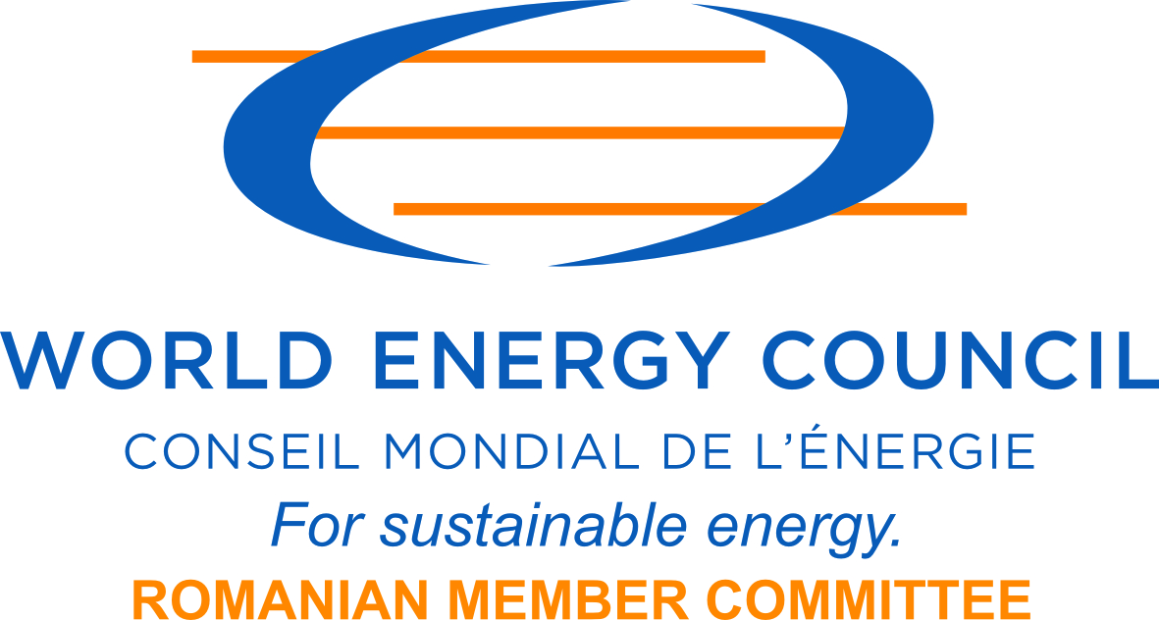 | Organised by  the Romanian National Committee  of the  World Energy Council | 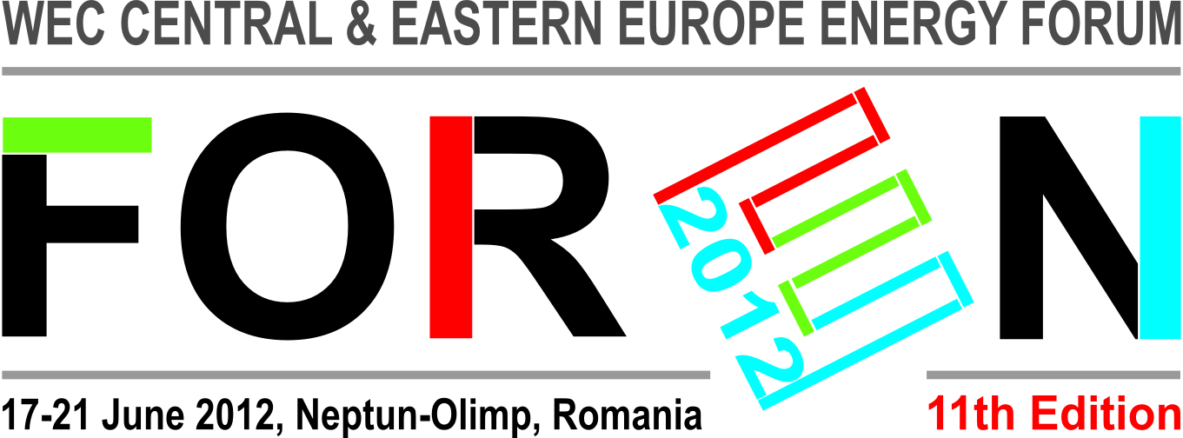
FOREN 2012  WEC CENTRAL & EASTERN EUROPE ENERGY FORUM National and Regional Energy Policies and Strategies. The Security of Supply

WORKSHOP AT FORUM LEVEL WF 2:
TOWARDS THE PAN-EUROPEAN TARGET MODEL FOR THE INTERNAL ELECTRICITY MARKET: FRAMEWORK GUIDELINE, NETWORK CODES, REGIONAL PROJECTS
Tuesday afternoon, June 19th 2012, 14⁰⁰-18⁰⁰ h
Neptun Conference Center, Tomis Hall

Organizers: WEC/ RNC and OPCOM SA

PROGRAMME

SESSION ONE: 14⁰⁰-15³⁰ h

Moderator:
- Victor Ionescu, General Manager Romanian Power Market Operator – OPCOM

Invited Speakers:
- Victor Parlicov, General Manager Moldova Energy Regulatory Authority
- Taavi Veskimägi, CEO of Estonian National Grid Operator – Elering
Regional SoS through common Nordic-Baltic Electricity Market
- Viorel Alicus, Director ANRE (TBC)
- Mirela Sandulescu, Head of Strategy Cooperation Office, OPCOM
Model of the European Internal Electricity

15³⁰-16⁰⁰ h | Cofee Break

SESSION TWO: 16⁰⁰-18⁰⁰ h

Moderator:
- Alexandru Sandulescu, General Manager Ministry of Economy, Trade and Business Environment

Invited Speakers:
- Hans-Arild Bredesen, Principal at Pöyry Management Consulting
Implementation of the SEE Regional Power Market
- Irinel Pavelescu, Engineer, Supply Department HIDROELECTRICA
Cadrul legislativ European dedicat implementarii modelului tinta al pietei interne de energie electrica
- Cristina Setran, Programme Director, Projects Development and Implementation, OPCOM
European Electricity Market Integration
- Ion Lungu, General Manager CEZ Trade Romania

Issues for discussion
- The legislative package no. 3, dedicated to the European internal market;
- The unequal development of national economies and their influence on energy markets.
- The European internal market for electricity: main targets
- The European legislative framework dedicated to implementing the target model of the internal electricity market (framework guidelines, codes of network).
- Intra-regional integration projects and inter-regional integration of electricity markets, from the perspective of creating the European internal market by the end of 2014.
- Particularities of instruments and market rules within the interconnected systems of electricity.
- The roles of the ability entities (ministry, regulating authorities, transmission and system operator, power exchanges) in the preparation and implementation of national framework and mechanisms, necessary for integration into the European internal market.

